# Inception Document

# ----Pet Management System

## Overview (vision and business control)

Pet management provides many benefits to the users and administrators. It will have all the records of pet even pet-information updates, and information will be given in details to the user or pet owner. Additionally, that will remind the users what their pet is going to do. Moreover it will also show the schedule, according to their pet respectively. It will be assumed like their family doctor who is concerned about the pet. Our team will depend on OOT (Object-Oriented Technology) to design the functions of this system.

## Functions Analysis --- Use-Case model

* Main use-case. This main use-case contains a user and administrator(s), and almost all the operations can be finished in the pet_management_system. It shows a link between user and the administrator to pet_managment_system.

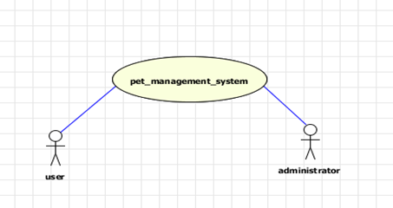**Chart 1**

* Client sub-system. This sub-system is the user’s operations which is a user sided view. This diagram illustrates that the user has to register into the pet management system firstly. Moreover, after going through such stage user is accessible to log in and he can see all his details and can edit it if he wants to. He can view all the details about the pets – its bread, kind and all that addition to its services. The function of service_info inquiry has a service reservation function which can be used to select exact services what he is looking for. Moreover, the service_reservation generates four sub-categories as medical_care, food reservation, pet_care_lecture and aesthetic_services. Furthermore, the user can also check the notifications (this would be implemented by only a message or a simple app).

**Chart 2**

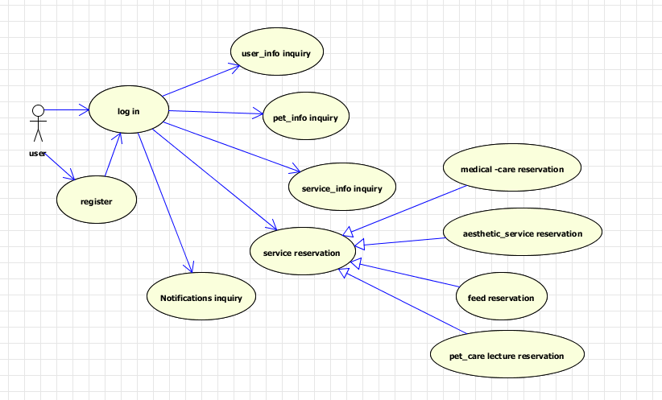

* Administrator sub-system. The diagram below shows all features, categories and sub_categories defining administrator side view. This administrator system is used to administrate the whole information and services by the administrator. At first, the administrator must have valid ID to log in and after that he or she can manage managers’, users’ and pets’ information (add, deletion, edit and inquiry). Moreover, the administrator can manage the service information from the background. The options which the administrator can view is admin_info_managment, user_info_managment, pet_info_managment, service_info_managment which will be followed by their sub-categories which clarifies each and everything.

# Chart3

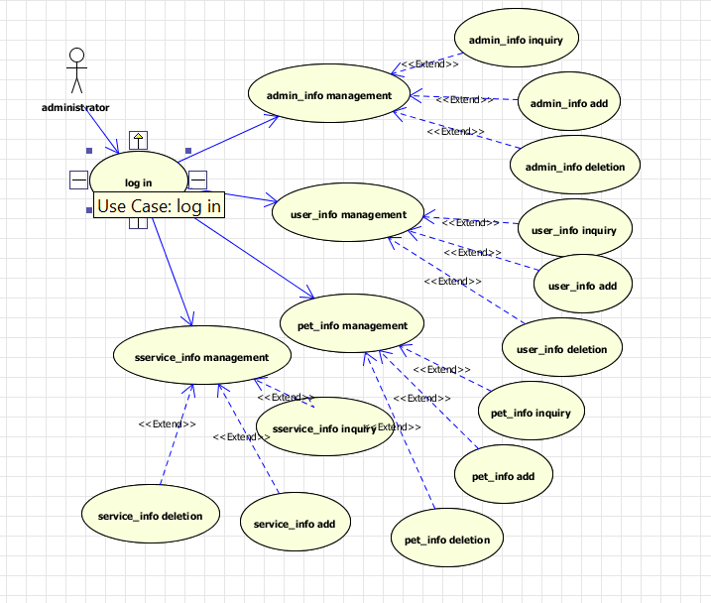

## Supplementary specification

This project will use the architecture of Petshop4.0. However, it seems to complicated when using a three-layer architecture(presentation layer, business logic layer and data access layer) on the sample application so that we would like to simplify this architecture to just two-layer system: presentation layer and background layer.

## Glossary-Relationship Analysis--E-R Model

E-R diagram (Entity Relationship Diagram) provides a vision between Entities, attributes and relationship. There are five Entities: pets, user, service, administrator and notification, and they have many different attributes which are illustrated in chart 4 shown below.

**Chart 4**

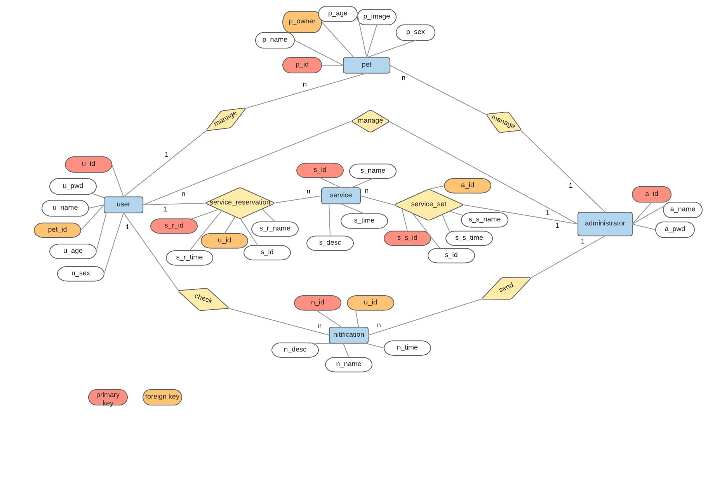

## Glossary-Data dictionary

This chart 5 shows the entity name (user, pets, administrator, services, notification, service reservation and services set), field name describing its attributes with data types, field size and keys.

## Chart 5

## Risk List and Management Plan

* Limited team members
* Learning website designing
* Moderate software development experience
* How to use Bluemix appropriately
* Setting target of completion
* Working and helping each other in every phase

## Interface Design

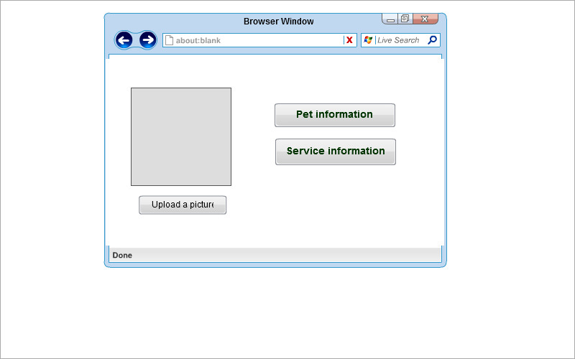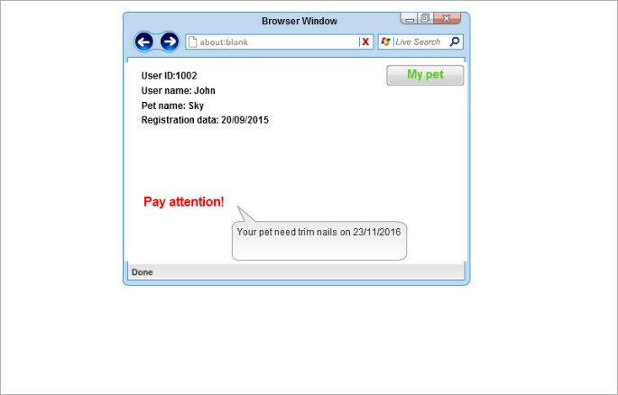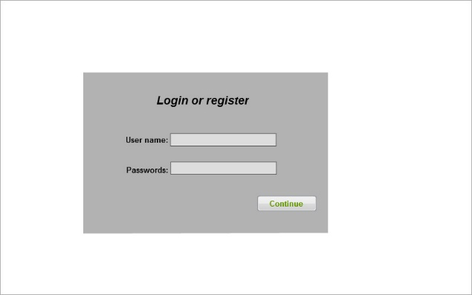A user can receive notification from the system and check the information of his pet.

## Phase plan and software development plan

In phase 1, we have finished the preliminary design and figured out the structure of database. In next phase, we are going to focus on developing this software including elementary implementation of some certain functions and some UI design. The language we are going to use is C# and the development tool will be Visual Studio. Moreover, the database management tool is MySQL.

All our team members giving their best shot, anyone stuck in any phase we work out together to get it done, we are not well experienced but somehow learning. Therefore, our team members plan to do the familiar part individually and unfamiliar parts together.